SCIENCE DEPARTMENT

YEAR 11
HUMAN BIOLOGY EXAMINATION
SEMESTER TWO 2006

Student Name: |  |  | Teacher:

SECTION 2: Short Answers – 10 Questions – 130 marks – 40%
Answer the questions in the spaces provided. Answers are to be in BLUE or BLACK ink.
GRAPHS and DRAWINGS to be in pencil and labelled in ink.

TOTAL MARKS: 130

SECTION 2: SHORT ANSWER SECTION 130 MARKS
Fill in all answers in this booklet.
Spelling and grammar will count towards your mark.
This section is worth 40%.
Good luck.

1. Refer to the diagram below.
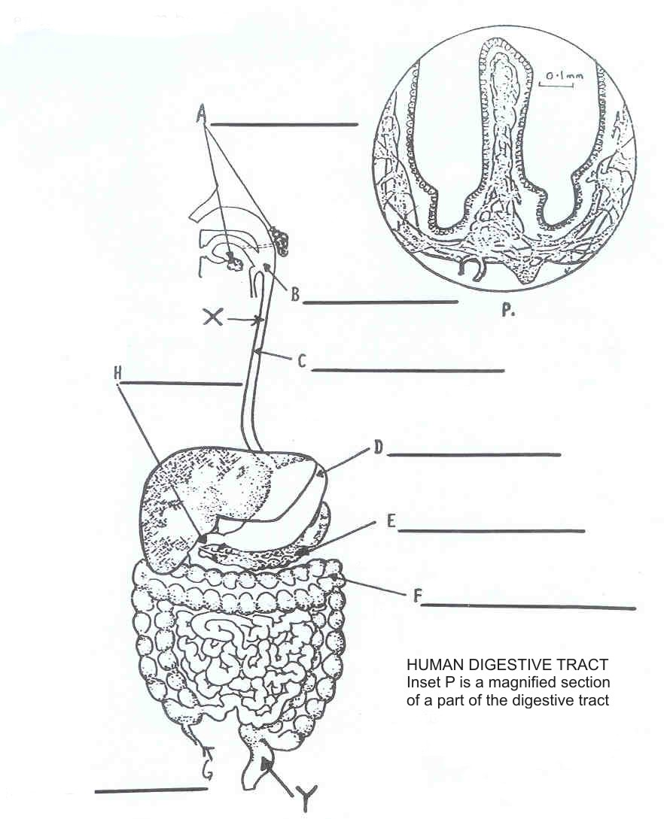

(a) Label the diagram of the human digestive tract that is above in the spaces provided (A – H). (8 marks)

(b) (i) Identify P. (1 mark)

(ii) In which region of the digestive tract is P found? (1 mark)

(iii) Name the major function of P and give two reasons why it is suited to this function. (3 marks)

(iv) Name and describe the process that moves food from point X on the diagram to point Y. (2 marks)

(c) For the parts D and A name: (4 marks)

(i) The enzyme(s) secreted by these organs.

D
A
(ii) The organic compounds digested in these organs.

D
A

2. Vocabulary
Write one or two word answers for the following descriptions. (Correct spelling is ESSENTIAL). (10 marks)

(a) Organic substances which are essential for health. Lack of some of them in the diet leads to deficiency diseases.

(b) The fluid form of food passed from the stomach to the duodenum via the pyloric sphincter.

(c) A lump of masticated food which is swallowed and which passes down the oesophagus to the stomach.

(d) A yellowish-green liquid secreted by the liver. Its function is to emulsify fats.

(e) The part of the small intestine which precedes the large intestine. It is the part concerned chiefly with absorption of digested food through villi.

(f) A cavity in the tooth which opens to the tissues in which the tooth is embedded by a narrow channel. It contains blood vessels and nerves.

(g) The removal of solid waste from the body.

(h) A general term for illness resulting from inadequate feeding. Usually due to lack of one or more essential components of the diet.

(i) The chief substance of a tooth, lying below the enamel and surrounding the pulp cavity.

(j) A cartilaginous flap which covers the opening of the trachea during the act of swallowing.

3. Complete the following table. (12 marks)

Food | Use(s) In The Body | Deficiency Disease/Symptoms
CARBOHYDRATE
FOLIC ACID
VITAMIN B1
VITAMIN D
CALCIUM
IRON

4. Refer to the diagram below.
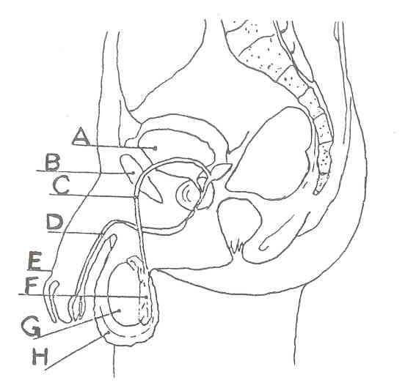

(a) Name the structures labelled. (8 marks)

A |  | E
B |  | F
C |  | G
D |  | H

(b) Which structure produces the hormone responsible for male secondary sexual characteristics? (1 mark)

(c) In which organ is mature sperm stored? (1 mark)

(d) Which of the labelled structures has no reproductive function? (1 mark)

(e) Through which structure do sperm leave the body? (1 mark)

(f) The testes develop in the abdominal cavity then descend into the scrotal sac. Why is it necessary for the testes to descend into the scrotum? (1 mark)

(g) Vasectomy is an operation used to sterilise men. Explain what structures are operated on and how the technique prevents conception. (2 mark)

(h) Why is castration an unsuitable procedure for male sterilisation? (1 mark)

5. (a) Label the following diagram below. (6 marks)
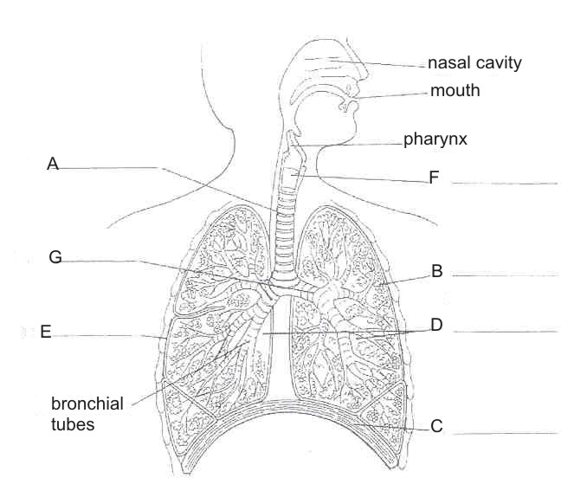
A
B
C
D
E
F

(b) What is the name of the space in which the heart lies? (1 mark)

(c) What is the name of the fluid covering B? (1 mark)

(d) Describe the function of C during (2 marks)

(i) inspiration

(ii) expiration

(e) Describe the purpose of the cartilage located in structure A. (1 mark)

(f) Describe THREE ways the nasal cavity cleanses air that is inspired. (3 marks)

(i)
(ii)
(ii)

6. Number of notified cases of Gonorrhoea and Syphilis in Western Australia for the years 1985-1996.

Year | Gonorrhoea | Syphilis
1985 | 1700 | 380
1986 | 1580 | 290
1987 | 1080 | 300
1988 | 1030 | 250
1989 | 750 | 260
1990 | 730 | 200
1991 | 720 | 285
1992 | 850 | 350
1993 | 830 | 170
1994 | 850 | 120
1995 | 860 | 100
1996 | 870 | 90

(a) Plot the results on a line graph. (6 marks)

(b) Give an explanation for a drop in both diseases in the early 1990’s. (1 mark)

(c) Complete the table. (6 marks)

 | Hepatitis B | Genital Herpes
Cause
Symptoms
Treatment

7. (a) Describe TWO physiological aspects of ageing. (2 marks)

(b) Complete the following table. (8 marks)

 | Advantages | Disadvantages
Breastfeeding
Bottle Feeding

(c) Describe, in reference to developmental milestones, how you would distinguish between a 2 month old baby and a 6 month old baby. (3 marks)

(d) List and briefly describe the three patterns involved in motor development.
(6 marks)

(i)

(ii)

(iiii)

8. Refer to the following diagram.
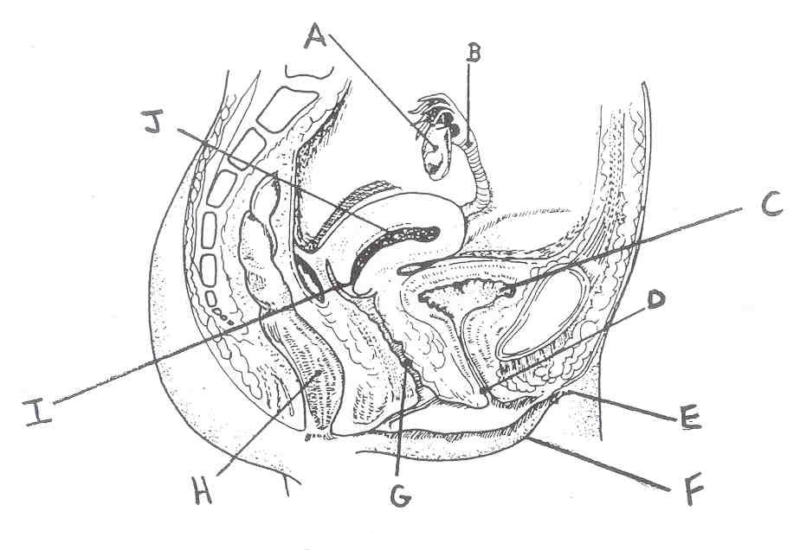

(a) Give the name and function of parts labelled B, G, C. (6 marks)

B
G
C

(b) Explain the event associated with organ A every month. (1 mark)

(c) The process of female sterilization involves which part on the above diagram?
(1 mark)

(d) Each ejaculation of a healthy, fertile male contains 100-400 million sperm. State why so many sperm are needed. (1 mark)

9. Complete the table below. (9 marks)

Hormone | Site of Production | Organs Targeted | Effects
FSH
LH
Oestrogen

10. Refer to the diagram below.

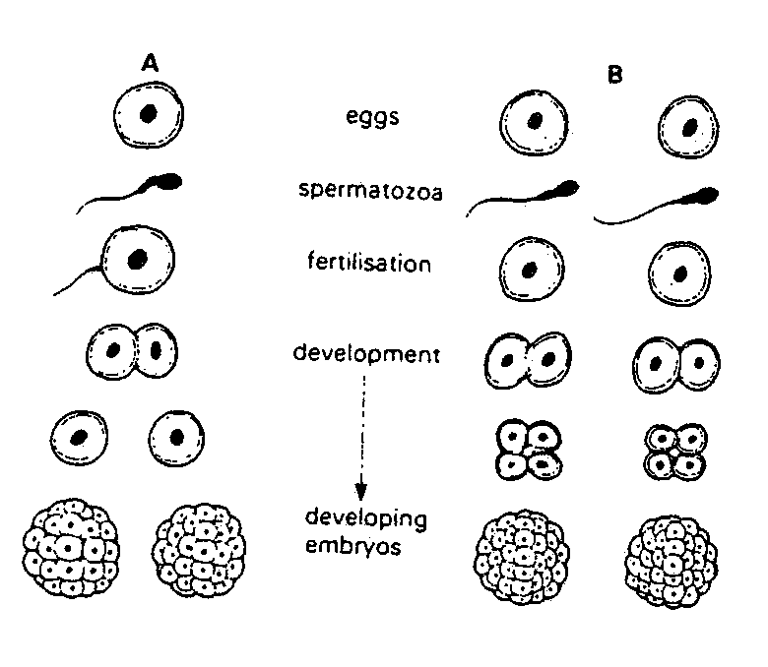

(a) What kind of twins would you expect in column A? (1 mark)

(b) What kind of twins would you expect in column B? (1 mark)

(c) Give a reason in each case to support your answers to parts A and B. (2 marks)

A

B

(d) Why are the twins in column A always of the same sex? (1 mark)

(e) Explain what is meant by cleavage and comment on its significance to the early development of the embryo. (2 marks)

(f) Explain the purpose and importance of the amniotic sac to the developing embryo. (2 marks)
11. The following diagram shows two similar models of a region of the human alimentary canal.
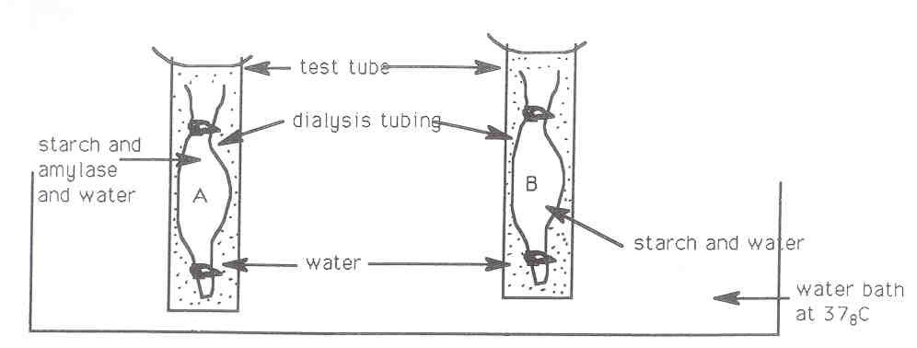

The water in the test tubes surrounding the dialysis tubing was tested with standard food test reagents at the start of the experiment and again after one hour. The results show neither starch nor sugar was present in the water surrounding Tubing A nor Tubing B at the start of the experiment.

(a) What results would you expect after one hour when the water surrounding the tubings was tested for starch and sugar? (1 mark)

(b) Name a reagent that tests for the presence of a reducing sugar. (1 mark)

(c) What is the purpose of Tubing B? (1 mark)

(d) What in the human body does the liquid surrounding the dialysis tubing represent? (1 mark)

(e) If the experiment was repeated with the two test tubes placed in the refrigerator instead of a water bath, how would you expect the results to differ? Explain the reasons for the difference. (2 marks)

